Push Notification

Why is push notification?

**Push Notifications** are messages sent by apps that pop up on users' devices, and their function is to deliver information and improve engagement.

Types of notifications:

1. Big text notification
2. Big picture notification
3. Notification actions
4. Directory plan notification
5. Inbox style
6. Message style notification

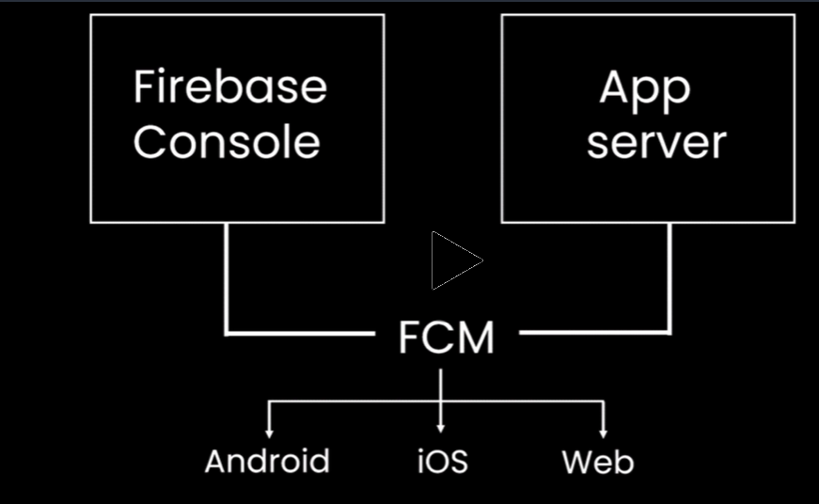

**Create a Firebase Console steps:**

1. Go to google and type “Firebase console” and take to following link

<https://console.firebase.google.com/>

1. Click on Add project menu and create a new project for push notification

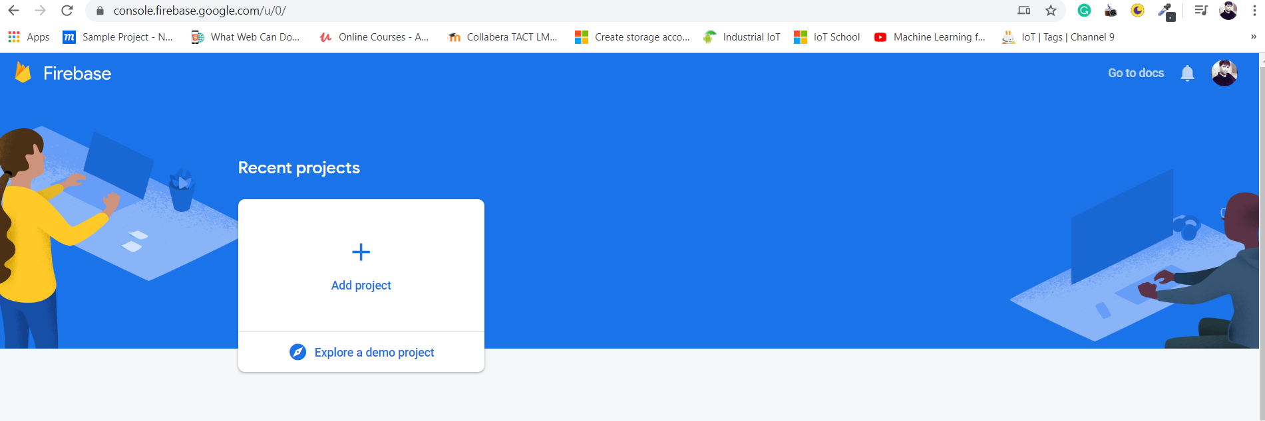

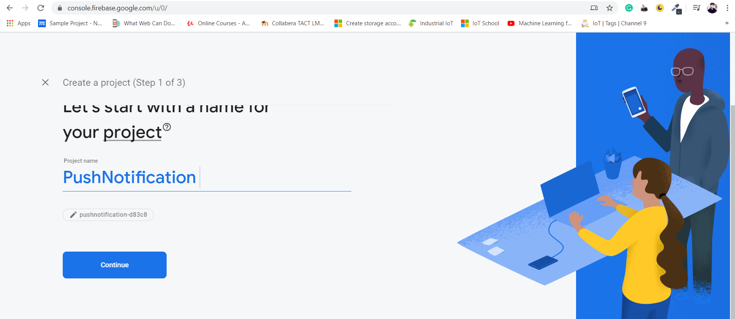

1. If we required google analytics, shall be enable following link to do analytics, if not required, disable the button

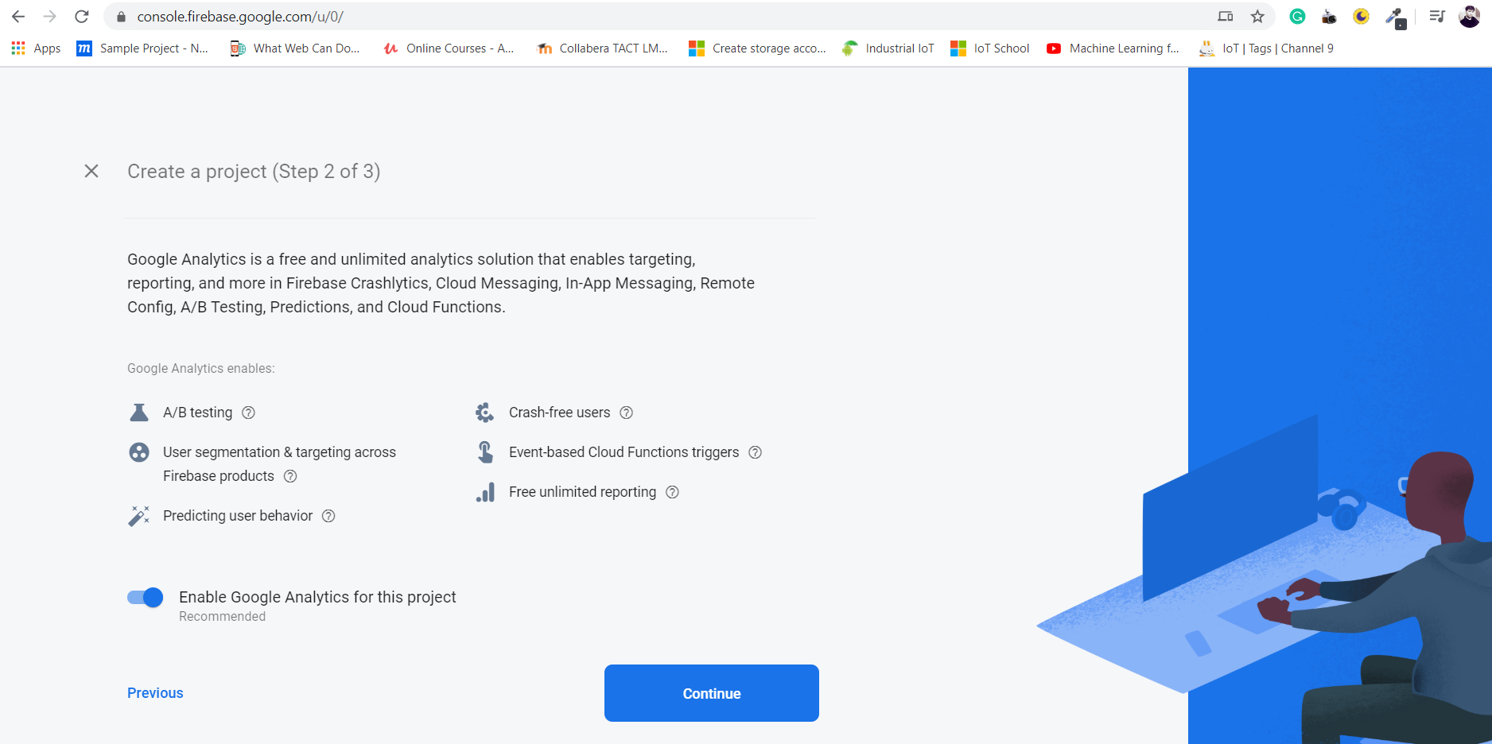

1. Shall redirect to dashboard page where we can create generate and configure to our mobile app push

There are three push notifications applications will support 1. Android 2. IOS and 3. WebApp

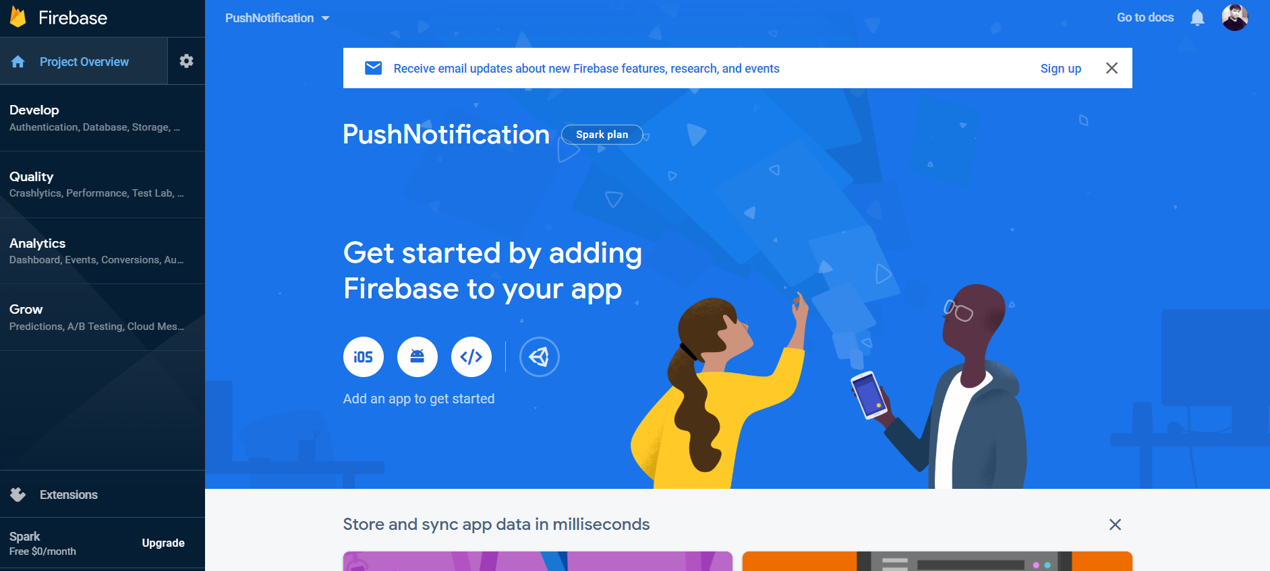

1. Choose android icon to integrate android application and we have provide following to register the app
2. Android package name
3. App nickname (optional )
4. Debug signing certificate SHA-1

Follow the steps to complete Register App

1. To fill package name , use package in our application MainActivity.java

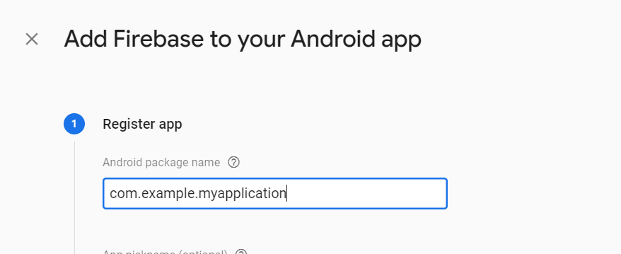

1. App nickname is optional
2. To get Debug signing certificate SHA-1 in our gradle script, App folder double click “signing report”, you will able to view SHA1 script console

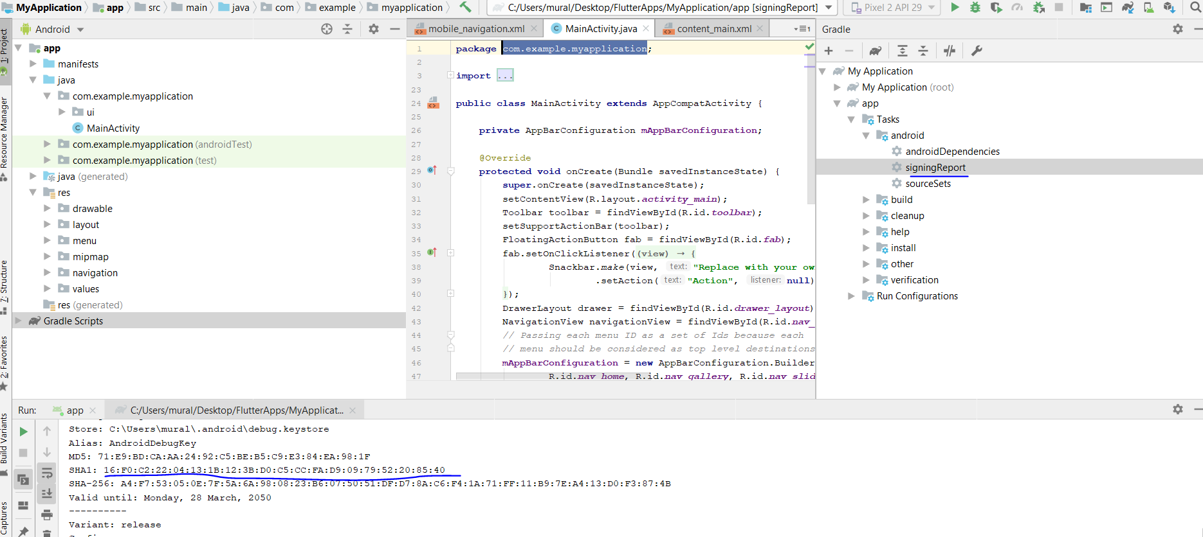

1. Click on Register App

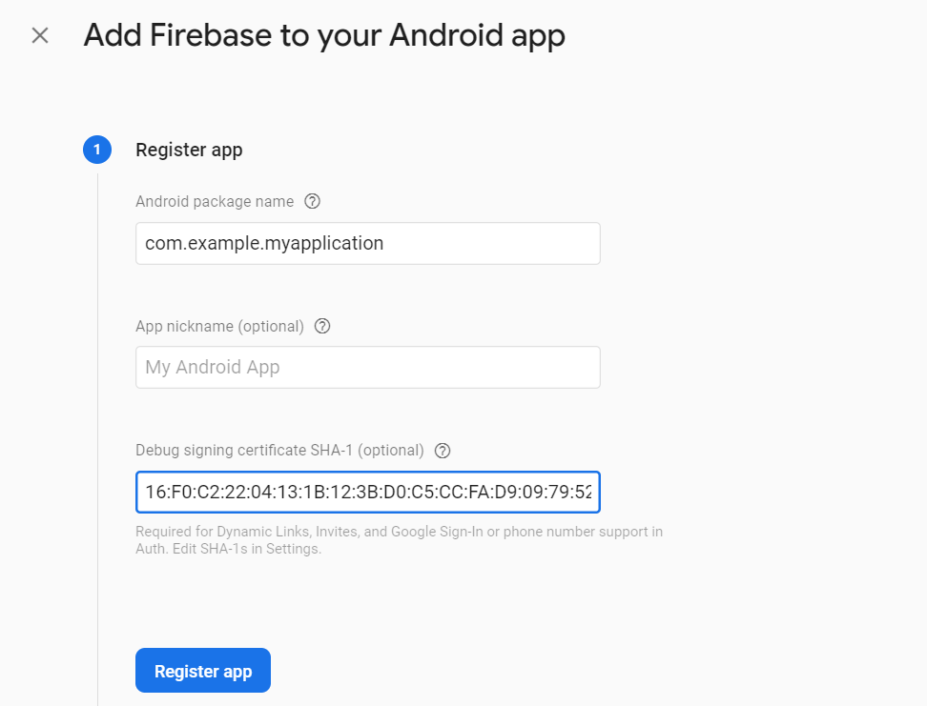

1. Post register app, FC generate the “google-service.json” file and click on download button

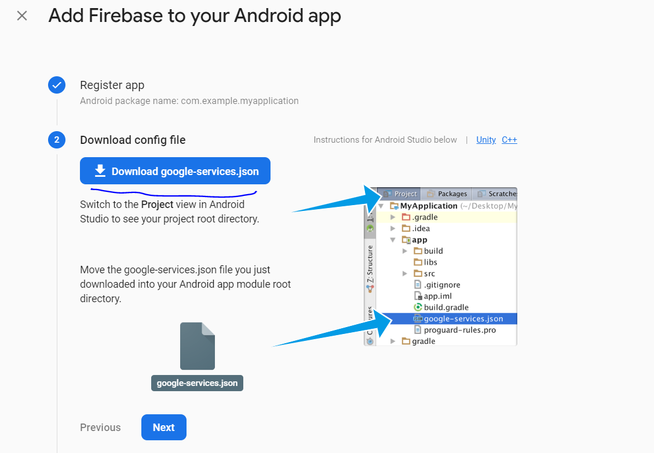

1. Can include gradle lib dependencies so click on Next button and include following script to the project

Project-level build.gradle (<project>/build.gradle):

buildscript {  
  repositories {  
    // Check that you have the following line (if not, add it):  
    google()  // Google's Maven repository  
  }  
  dependencies {  
    ...  
    // Add this line  
    classpath 'com.google.gms:google-services:4.3.3'  
  }  
}  
  
allprojects {  
  ...  
  repositories {  
    // Check that you have the following line (if not, add it):  
    google()  // Google's Maven repository  
    ...  
  }  
}

App-level build.gradle (<project>/<app-module>/build.gradle):

apply plugin: 'com.android.application'  
// Add this line  
apply plugin: 'com.google.gms.google-services'  
  
dependencies {  
  // add SDKs for desired Firebase products  
  // <https://firebase.google.com/docs/android/setup#available-libraries>

implementation **'com.google.firebase:firebase-messaging:17.3.4'**

}

1. Done with configuration with android and FC
2. If we want to configure FCM REST API, required two parameters 1. Server key and 2. Sender ID

To get those navigate to FCM console and click on project overview setting icon and select project settings link and choose “Cloud messaging” tab

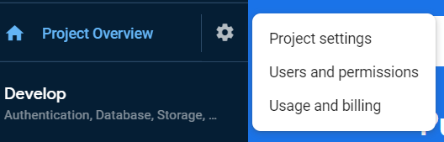

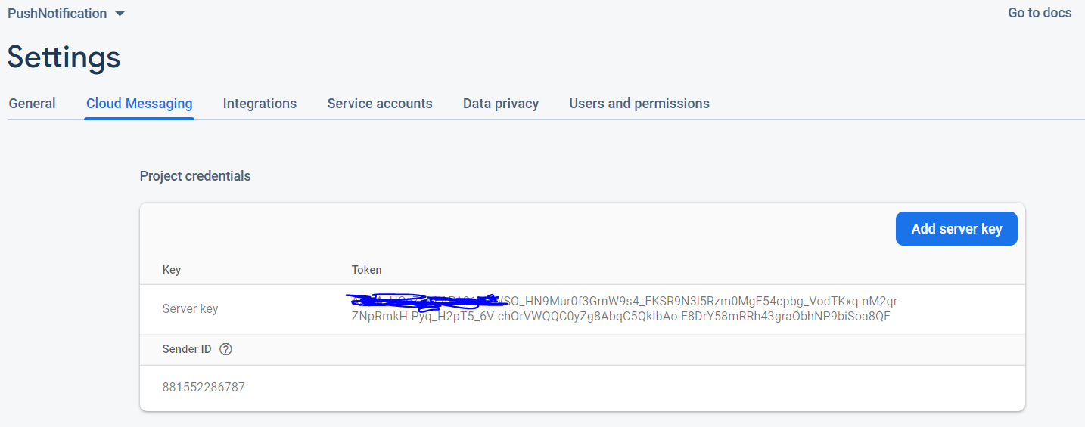

1. There are few ways to send of Notification services
2. All Users (Can be push to all who all are installed our application, without payload and with payload)
3. Based on subscribe id send the notification

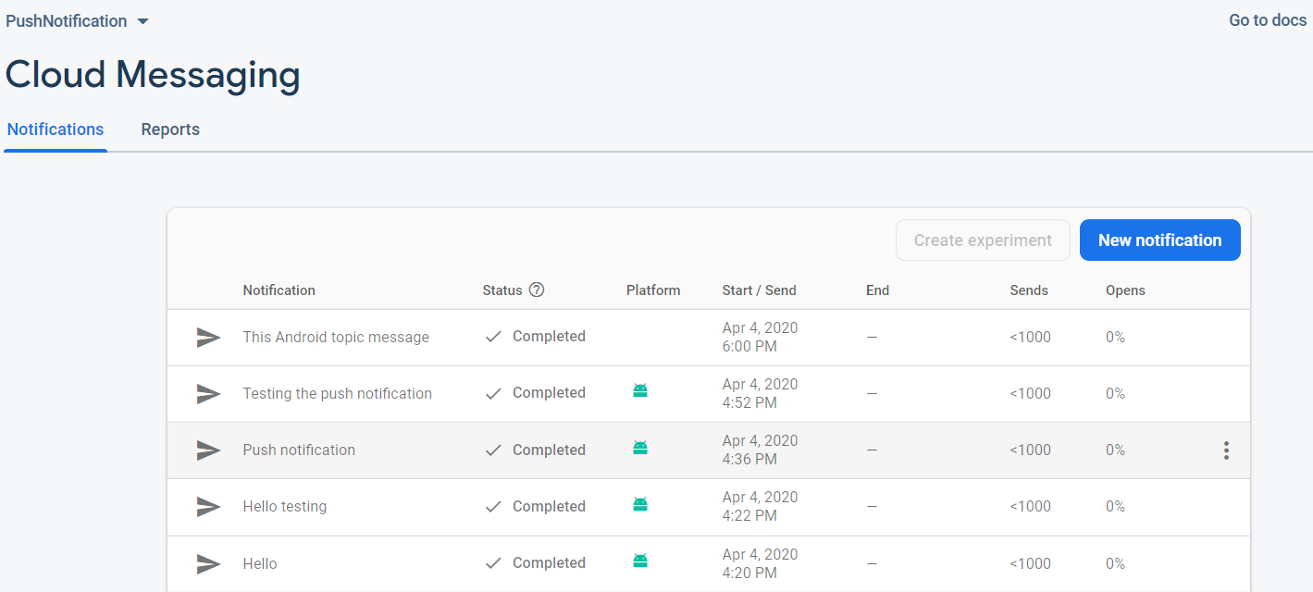

1. Unique person using FCM instance id (Source code available)

<https://firebase.google.com/docs/cloud-messaging/http-server-ref>

using postman tested the notification, reference below

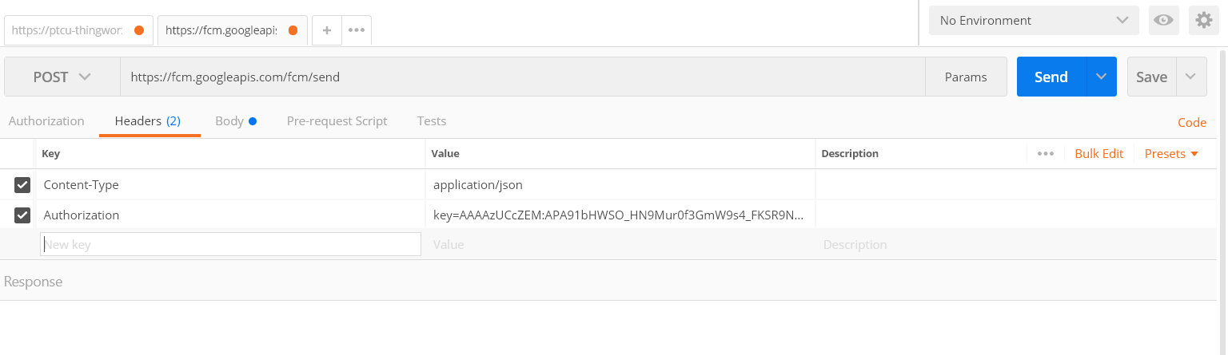

url : <https://fcm.googleapis.com/fcm/send>

Content-Type: application/json

Authorization: Server key (Refer above #8)

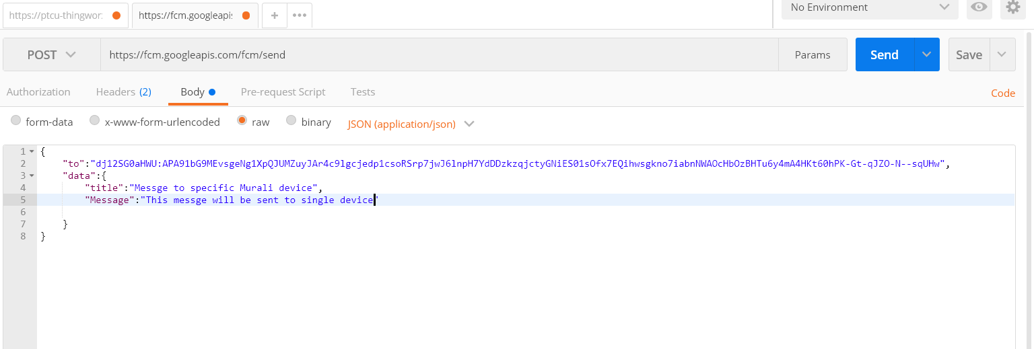

To: FCM instance id

Data: which we send to user

1. There are few ways clear the FCM instance id, so we have to fetch the FCM id and store into server

* when user uninstall or reinstall the app
* when instance id is deleted by app for some reason
* when user clears app data
* when app is installed on new device

*Fetching method:*

**public void** onNewToken(@NonNull String s) {  
 **super**.onNewToken(s);  
}

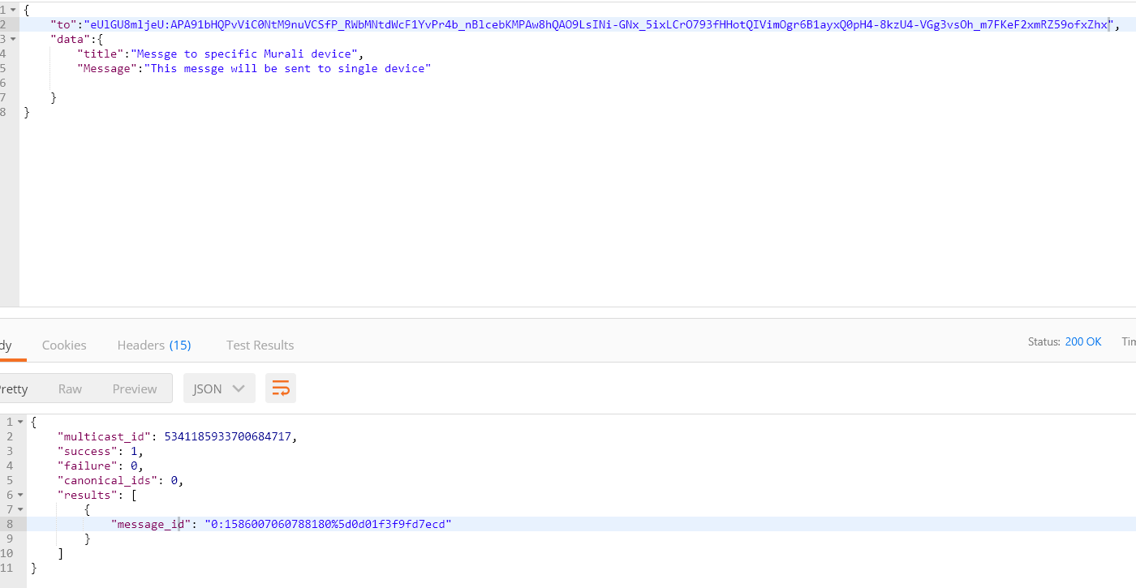

Post sending push, can get success result id

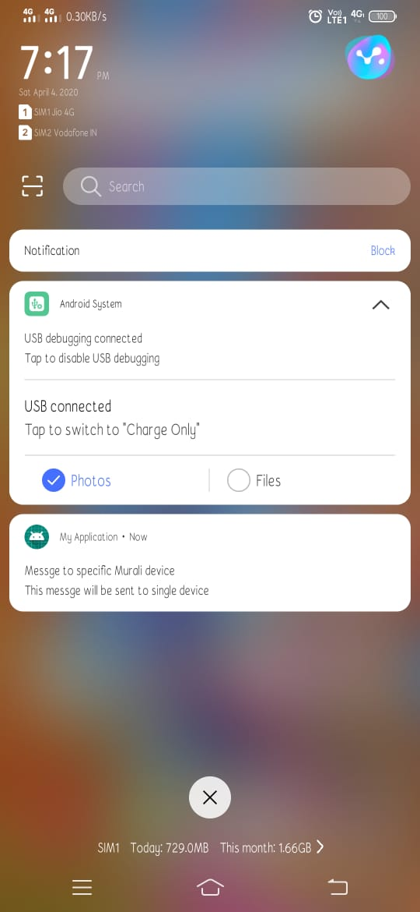

To send Group pf users follow the same

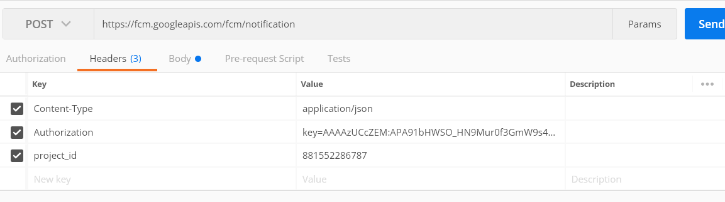

url : [https://fcm.googleapis.com/fcm/notification](https://fcm.googleapis.com/fcm/send)

Content-Type: application/json

Authorization: Server key (Refer above #8)

Project_id=sender id (Refer above #8)

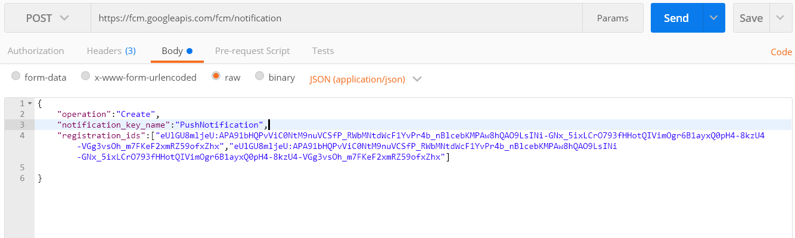

Operation: we are going to create

Notification key : Group name

Id : array of device id

Post submit the group user, on click of send button “notification_key” will generate like follow

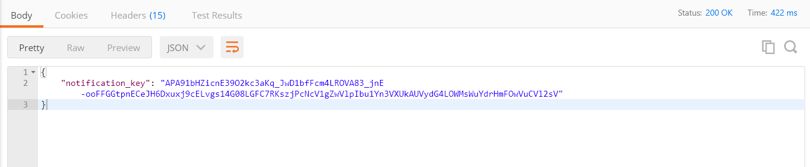

We can use the “notification_key” to send group users push notification like follow

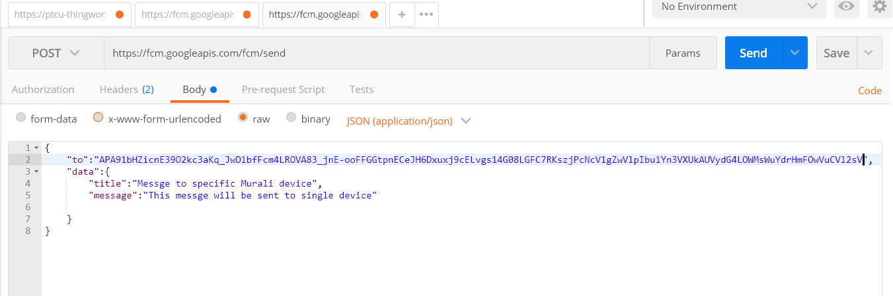

Please download source code from following link

<https://github.com/CodeEZ-Dev/PushNotification.git>